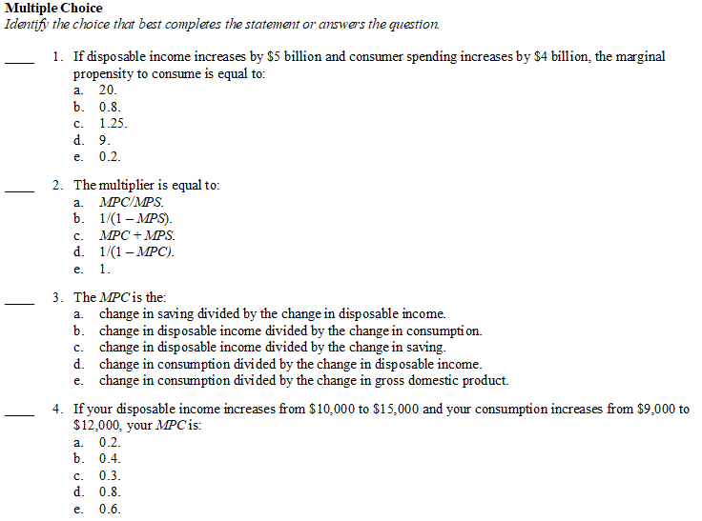
1 | B | 6 | C | 11 | D | 16 | C | 21 | D
2 | D | 7 | B | 12 | A | 17 | D | 22
3 | D | 8 | D | 13 | A | 18 | D | 23
4 | E | 9 | A | 14 | C | 19 | C | 24
5 | B | 10 | B | 15 | C | 20 | B | 25

Multipliers and Consumption Function
